|  |  |
| --- | --- |
| **Date** | 11 November 2022 |
| **Team ID** | PNT2022TMID05082 |
| **Project Name** | Inventory Management System |
| **Batch number** | B11-5A1E |

# PROJECT DEVELOPMENT PHASE SPRINT 1

As an admin, I can login and manage the inventory

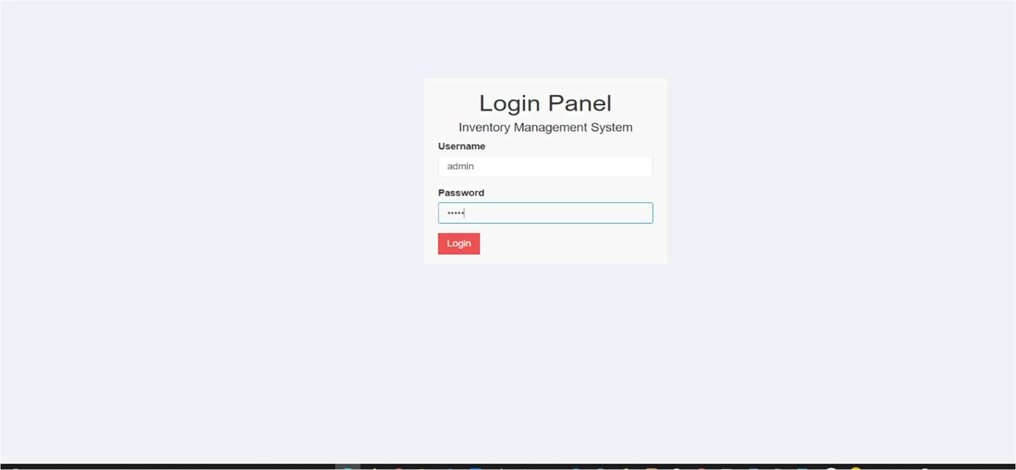

# DASHBOARD

I have successfully login to the next page



We can login for user account also

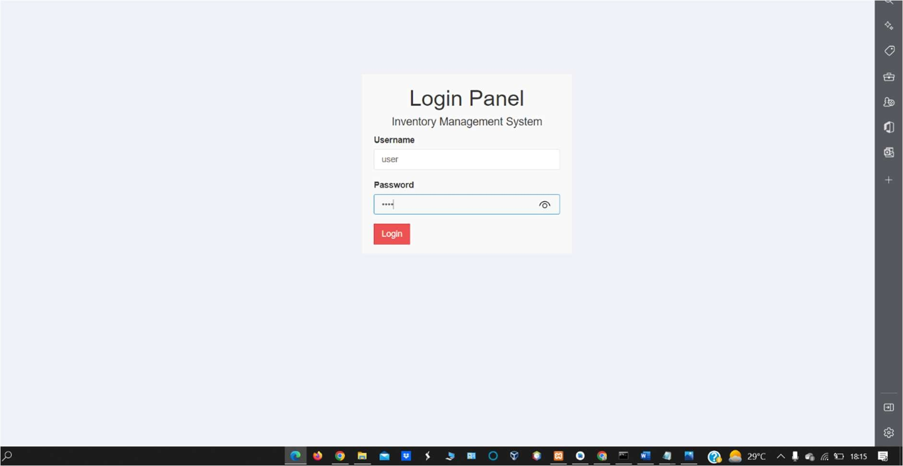

User have their respective roles

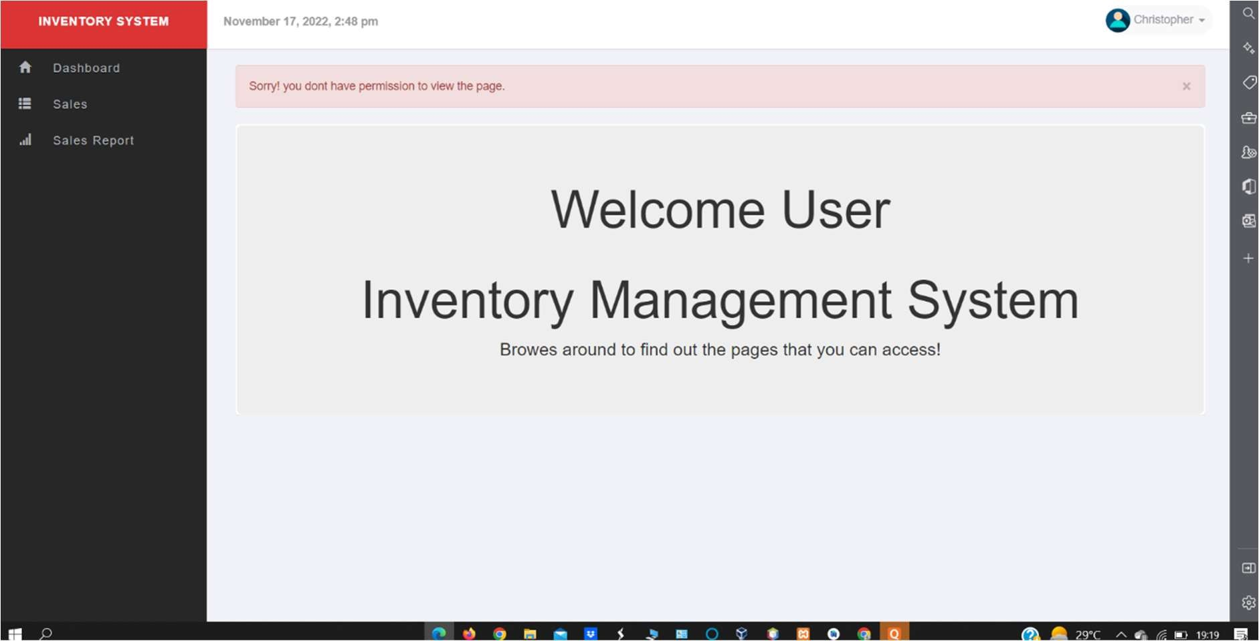

Special user have only access to products and media

